Java collection

**Explain collection hierarchy**

- Collection Interface

- All implement the above interface only Map does not implement it.

* **List** Ordered , contains duplicate, index base search.
* **Set** Unordered , Doesn't Contains Duplicate,index base search not supported
* **Queue** Fifo approach added at rear and removes from front
* **Maps** do not implement the collection.

**Java.util.map**

* Represent a key value pair
* Map does not implement a collection interface.
* Unique key can have duplicate values

Classes

**List**

* **Arraylist** =not sync , dynamic resizing ,50%
* **Linked list** = maintain insertion order , not sync

**Stack =) Vector**

* Sync
* Double
* Legacy
* Insertion order

**Stack**

* LIFO

**Set**

Hash set SortedSet

TreeSet

**Hash set vs Treeset**

* No order

**Set vs Map**

* Value key and value
* Can iterate convert to set to iterate

**Hashmap vs Treemap**

* No order vs order asc

**Collection vs Collections**

* Interface class
* Normal functionality list set and queque Vs sort and sync

**Hashing principle**

* One hashCode calculated base on key
* Index number generated based on hashCode e.g. 456
* On bucket on particular index it will store node inside linked list e.g. 5 index

**Hashcode characteristic**

* Key and value should override hashCode and equal
* One null key allow
* Multiple null value allows
* Hashmap not thread safe
* Hashmap can iterate with keyset entryset
* Unordered
* HashMap(): It is the default constructor which creates an instance of HashMap with initial capacity 16 and load factor 0.75.
* Extends Abstract Map and implements serializable and clonable
* 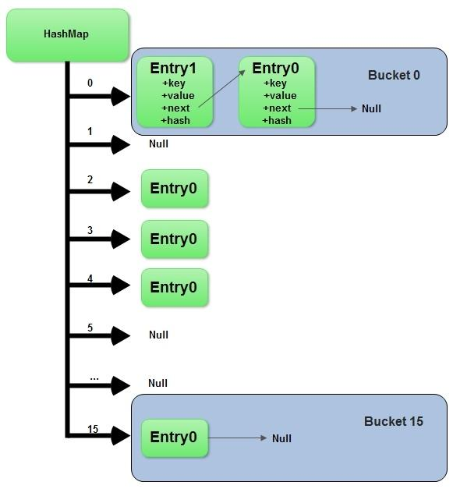

**Hashcode**

* Return integer number
* Two unequal objects can have the same hashCode.

**Why override equal ?**

* We can compare object base on attribute value. E.g. compare employee

**Why equal and hashCode require to override?**

* Hashmap and hashset depends on equal and hashCode contract

**Collision**

* same hashCode
* same index
* linked list multiple nodes store O(n)
* linked list reach to threshold value Java convert to balanced binary tree O(log n)

**Generic benefits**

* don’t need typecasting
* typesafe and error check at compile time

**Hash collision**

* Two different key with same hashCode value known as has collision
* Two different key kept in single bucket to avoid collision

**Sort collection**

* treeset and treemap
* treemap sort base on key
* want to sort using value use comparator and provide inside constructor.
* LinkedHashmap or sortedmap to sort map base on value

**What if we don't override hashCode method?**

* It will use the hashcode method of object class.
* This method returns the memory address of the object in hexadecimal format.
* Same when the same memory address is not base on value of object.
* It will not consider value of object and can override existing value.

**Concurrent Hashmap**

* Internally use hash table.
* Thread Safe.
* Null Not Possible
* Any number of thread without locking.
* the Object is divided into a number of segments according to the concurrency level.
* Default is 16
* **Segment Locking or Bucket Locking**
* Update Must lock the thread

**ConcurrentHashMap vs Hashtable**

* Assume Hashtable and ConcurrentHashMap are two types of Homes.
* Hashtable locks home's main door.
* ConcurrentHashMap locks specific room door instead of main door.

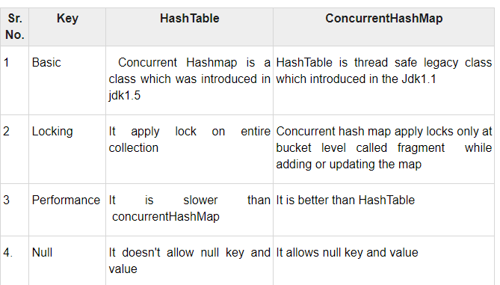

**Polymorphism**

**Poly :-** many

**Morph:-** Forms

**Many Forms :-** The word polymorphism means having many forms.

**Ability To display Message in More Then One Form :-** We can define polymorphism as ability of message to display more then one form.

**Real Life Example :-** a person at same time can be father , husband , employee.

A same person possess different behavior at different time.

**VLC : - mp3 avi etc**

**Single Action Different Ways**

1. **Compile-time polymorphism:** It is also known as static polymorphism.

This type of polymorphism is achieved by function overloading or operator overloading.

But Java doesn’t support the Operator Overloading.

2 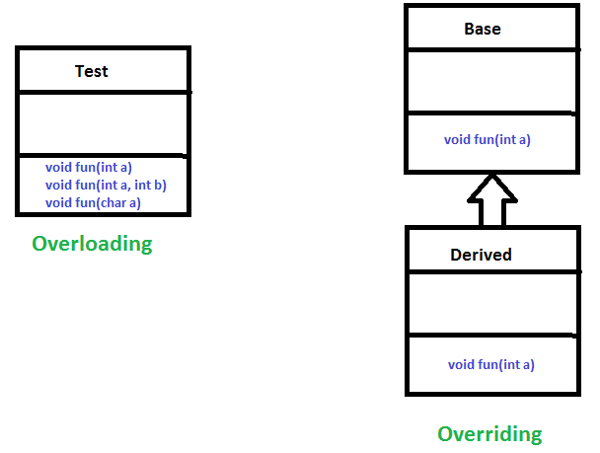

**Method Overloading:** When there are multiple functions with same name but different parameters then these functions are said to be overloaded. Functions can be overloaded by change in number of arguments or/and change in type of arguments.

**Runtime polymorphism:** It is also known as Dynamic Method Dispatch.

**Function Call Resolved At Runtime :-** It is a process in which a function call to the overridden method is resolved at Runtime.

This type of polymorphism is achieved by Method Overriding.

**Derived Class definition of base class :-** Method overriding, on the other hand, occurs when a derived class has a definition for one of the member functions of the base class. That base function is said to be overridden.

**Exception**

**2 Exception Handling in Java**

**Abnormal Condition :-** Exception is an abnormal condition.

**Event disrupt Normal Flow** :- In Java, an exception is an event that disrupts the normal flow of the program.

**Object thrown at runtime**

It is an object which is thrown at runtime.

**Mechanism To Handle Runtime Errors :-**

Exception Handling is a mechanism to handle runtime errors

ClassNotFoundException, IOException, SQLException, RemoteException, etc.

**Hierarchy**

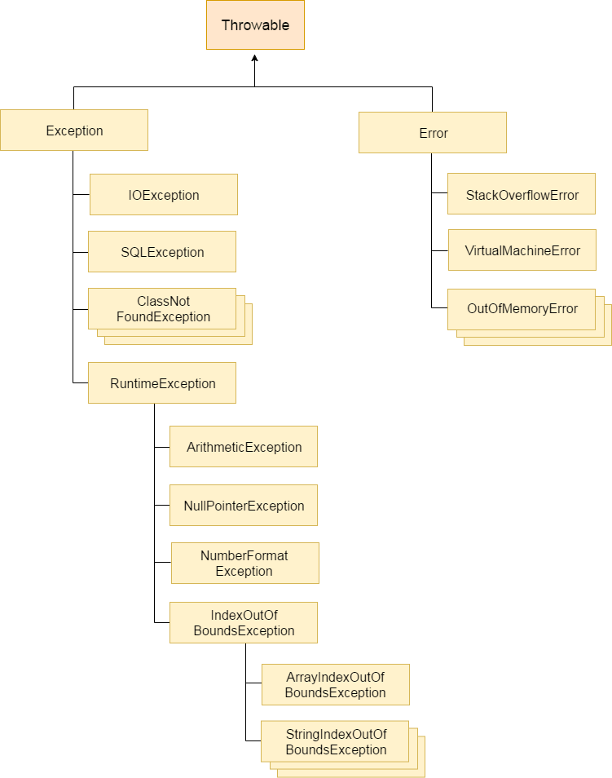

**Root class Throwable :-** The **java.lang.Throwable** class is the root class of Java Exception hierarchy.

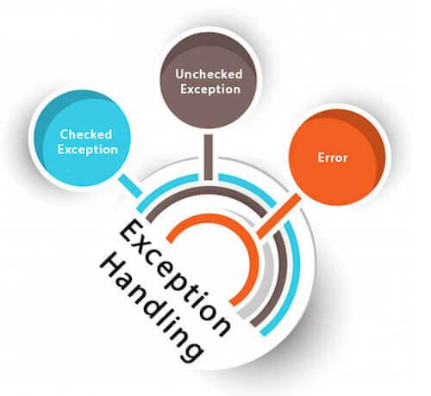

**1) Checked Exception**

**Checked at Compile Time:-** Checked exceptions are checked at compile-time.

**Inherit Throwable exc Runtime Exception & Error** :- The classes which directly inherit Throwable class except RuntimeException and Error are known as checked exceptions

**e.g**. IOException, SQLException etc.

**2) Unchecked Exception**

**Inherit Runtime Exception :-** The classes which inherit RuntimeException are known as unchecked exceptions

**e.g**. ArithmeticException, NullPointerException, ArrayIndexOutOfBoundsException etc.

**Checked at Runtime:-** Unchecked exceptions are not checked at compile-time, but they are checked at runtime.

**3) Error**

**Irrecoverable :-** Error is irrecoverable

**e.g**. OutOfMemoryError, VirtualMachineError, AssertionError etc.

**Java Exception Keywords**

There are 5 keywords which are used in handling exceptions in Java.

**Try: -**

**block** where we should put exception code**.**

**Followed by : -**

It is followed by catch and finally.

Can't use try **block alone**.

**Catch**

**Handle :-** Useful for handle Exception handling

**Followed By Finally :-**

**Cant use alone :-**

**Finally :-**

**Important code of program:-** it will execute either Exception occurs or not.

**Throw : -** The throw keyword used to **throw Exception.**

**Throws:-**

**As method signature**

**May Occur Exception:-**

* **Declare :'** The "throws" keyword is used to declare exceptions.
* It doesn't throw an exception.
* It specifies that there **may occur an exception** in the method.
* It is always used with method signature.

int a=50/0;//ArithmeticException

String s=null;

System.out.println(s.length());//NullPointerException

String s="abc";

int i=Integer.parseInt(s);//NumberFormatException

int a[]=new int[5];

a[10]=50; //ArrayIndexOutOfBoundsException

**Token base SSO**

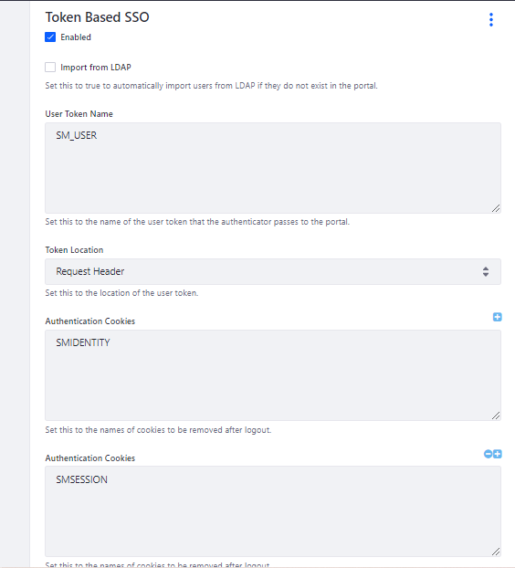

FailFast and FailSafe Iteration in Java Collection

Fail Safe – Do not throw any exception if any modification happen on collection.

Fail Fast – Throw Concurrent Modification Exception

ArrayList<String> al = new ArrayList();

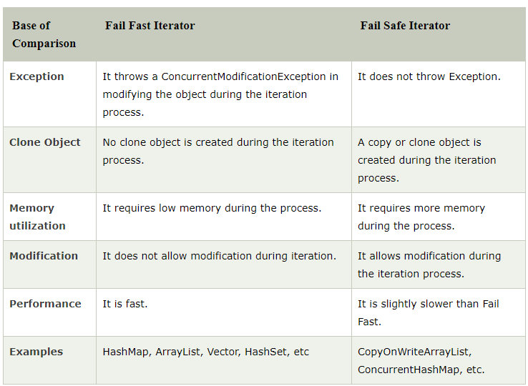

FailFast and Failsafe